# Reed Bunnell – Module 2

This document includes a flowchart for the selected program and space for debugging screenshots and notes.

## Flowchart for calculate_average()

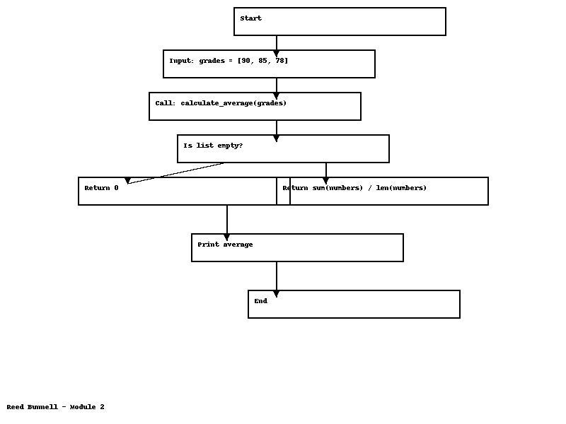

The flowchart above represents the structure of the calculate_average() Python function, including input, logic, and output.

## Debugging Steps

### Screenshot 3 – Final Step or Error Test

